Asset Tool User Manual

This manual provides instructions for using the Asset Tool, which automates the tracking of DITA, Resource, and Markdown assets ids in the AssetData.xlsx file present in the central location in SharePoint and sends notifications via Outlook

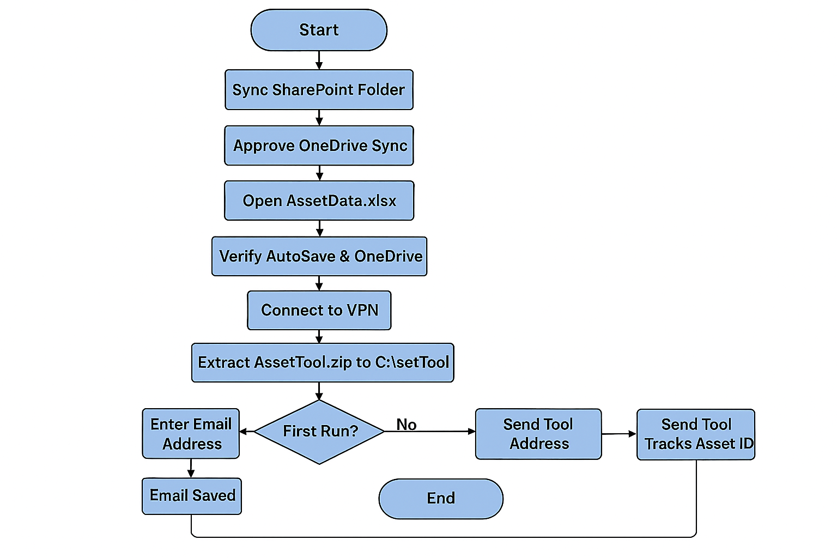

Prereq : Sync Sharepoint
Open the sharepoint link : Scale Enablement Group (SEG) - AssetID - All Documents
Click the sync button as shown below:
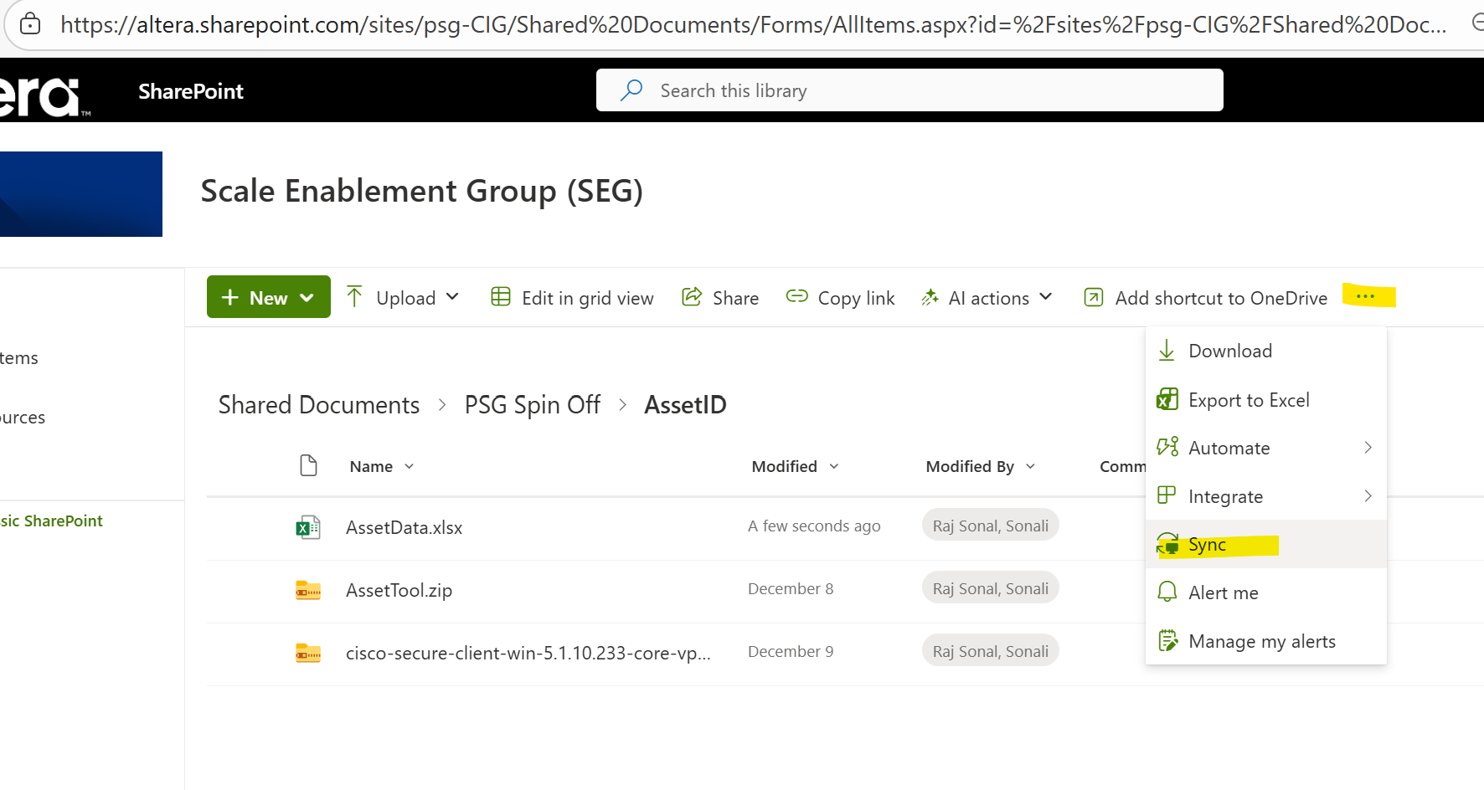
Approve OneDrive
- Browser will ask: “Open Microsoft OneDrive?”
- User clicks Yes
- OneDrive app starts syncing
If OneDrive isn’t running, Windows will prompt to install/start it.
Confirm sync location on the PC
After syncing, the folder will appear locally at something like:
C:\Users\sonali.rajsonal\Altera\Scale Enablement Group (SEG) – AssetID

Verify the synchronization worked:
Go to the location in your system:
C:\Users\<your_username>\Altera\Scale Enablement Group (SEG) – AssetID
- Open AssetData.xlsx locally
- Check top-left of Excel:
- It should say “Saved to OneDrive”
- AutoSave should be ON

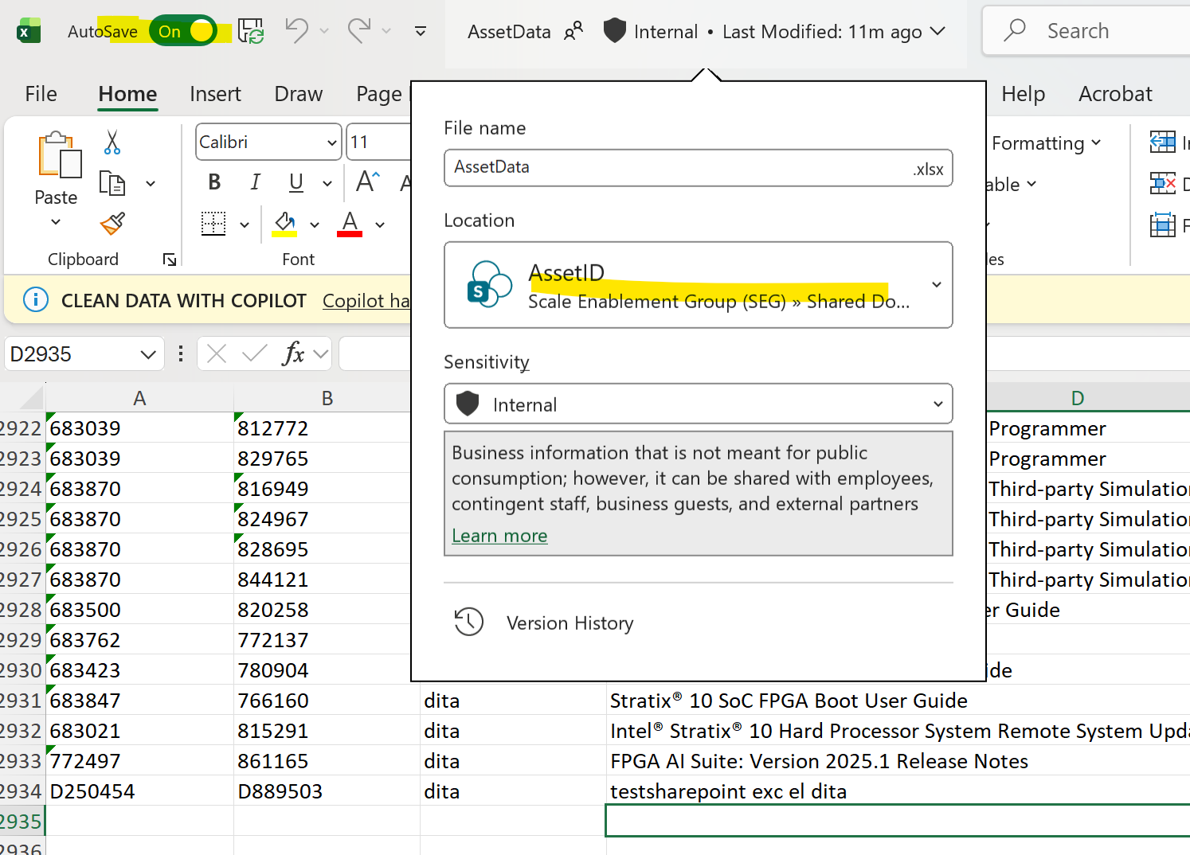

Please close the file and don’t use it later

Tool Access:
1.Connect To VPN using altera laptop and password
Extract the contents of the zip file from the below location to the location C:\AssetTool directory. AssetTool.zip

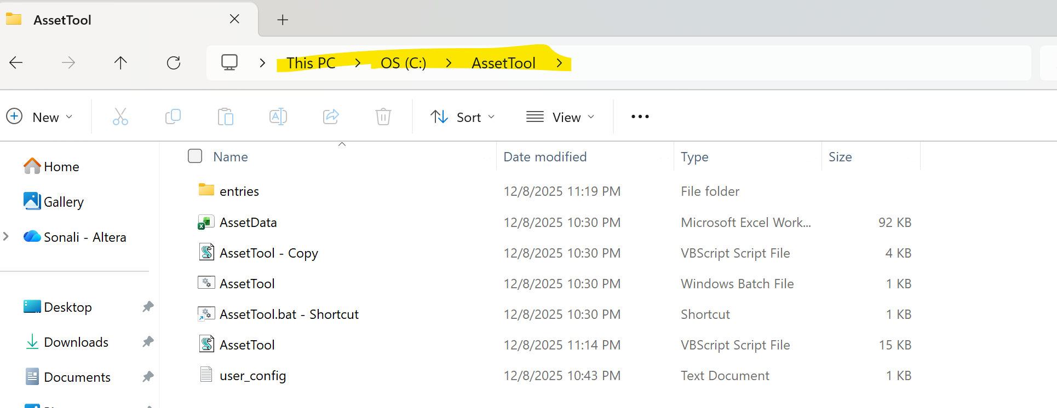

1. Initial Setup (First Run Only)
The first time you run the tool, it will prompt you for your email address and create necessary configuration files.
- Run the Batch File: Double-click the batch file (AssetTool.bat) located in C:\AssetTool [ or right click and create shortcut on desktop, run it from there].
- Enter Your Email: A window titled "Initial Setup" will appear.
- Enter your complete Email ID (sonali.raj.sonal@altera.com).
- Click OK.
- Result: Your email is saved to C:\AssetTool\user_config.txt and will not be requested again.
If you dont see this popping up , or see sonali.raj.sonal@altera.com in the window
Go to C drive : AssetTool folder and open user_config.txt 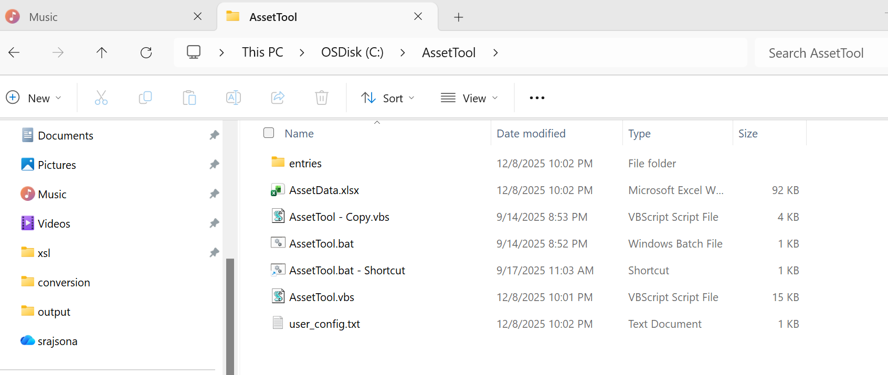

Replace sonali.raj.sonal@altera.com with your email and run the tool again
- Continue to Section 2.

2. General Operation: Starting the Tool
The tool must be run via the batch file to ensure proper execution.
- Open the Tool: Double-click the batch file in C:\AssetTool.
- Select Asset Action: A window titled "Asset Tool" will appear.
- Enter 1 for New Asset (Create a new Cluster ID).
- Enter 2 for Existing Asset (Add a new Origin ID to an existing Cluster).
- Click OK.

3. Workflow A: Creating a New Asset (Option 1)
Use this option when creating a brand-new piece of content that requires a new Cluster ID and its first Origin ID.
- Enter Asset Type: A window titled "New Asset Type" will appear.
- Enter one of the three supported asset types: DITA, Resource, or Markdown.
- This determines the ID prefix (D, R, or M) for both IDs.
- Click OK.
- Enter Asset Title: Enter the descriptive Title of the new asset.
If u want to cancel at this point, press cancel and close the terminal window.
- Confirmation: A final message box will appear, displaying:
- The newly generated Cluster ID.
- The newly generated Origin ID.
- The entered Asset Type.
- Completion: The script automatically handles:
- Saving the data to sharepoint
- Saving a copy of the entry to the text file directory (C:\AssetTool\entries\).
- Sending an email notification to you and the Architect (sonali.raj.sonal@altera.com).

4. Workflow B: Updating an Existing Asset (Option 2)
Use this option when creating a new version or variant of an existing asset that only requires a new Origin ID linked to an existing Cluster ID.
- Enter Existing Cluster ID: A window titled "Existing Asset" will appear.
- Enter the complete Cluster ID (e.g., D123456).
- Click OK.
- If the ID is not found, the tool will exit with an error.
- Enter Title: Enter the descriptive Title for this specific new Origin/version.
- Enter NEW Asset Type (Override): A window titled "Existing Asset Type Override" will appear.
- Enter the Asset Type (DITA, Resource, or Markdown) that corresponds to this new Origin ID.
- This input determines the prefix (D, R, or M) for the new Origin ID, regardless of the original Cluster ID's prefix.
- Confirmation: A final message box will appear, displaying:
- The new Origin ID that was generated.
- The Asset Type used for the Origin.
- Completion: The script performs the same save, logging, and email notification steps as the "New Asset" workflow.

Sharepoint Link Legacy site issue :
Few of you have been facing issues on the SharePoint access due to the name change of the site .
Some of you might see a different sharepoint url which is synced in you C drive as shown below:
Regular URL: [doesnt need a change]
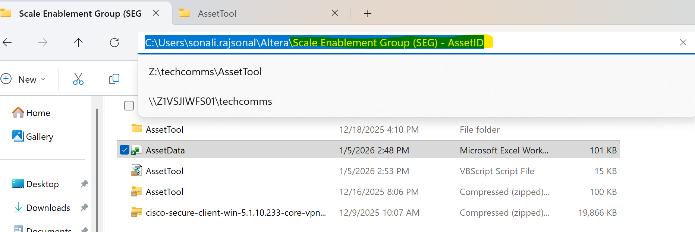

Legacy URL [Needs a change]

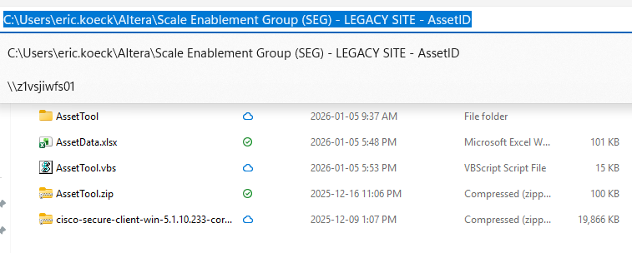

Right click on the AssetTool.vbs and edit in notepad

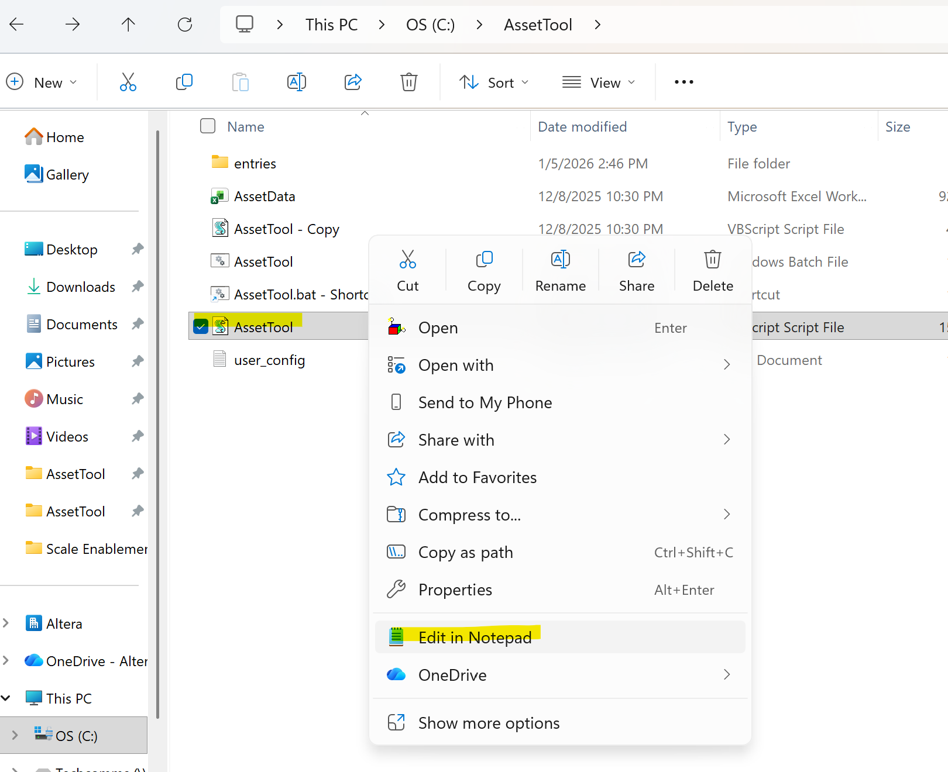

Look for the variable dataFile as show below :
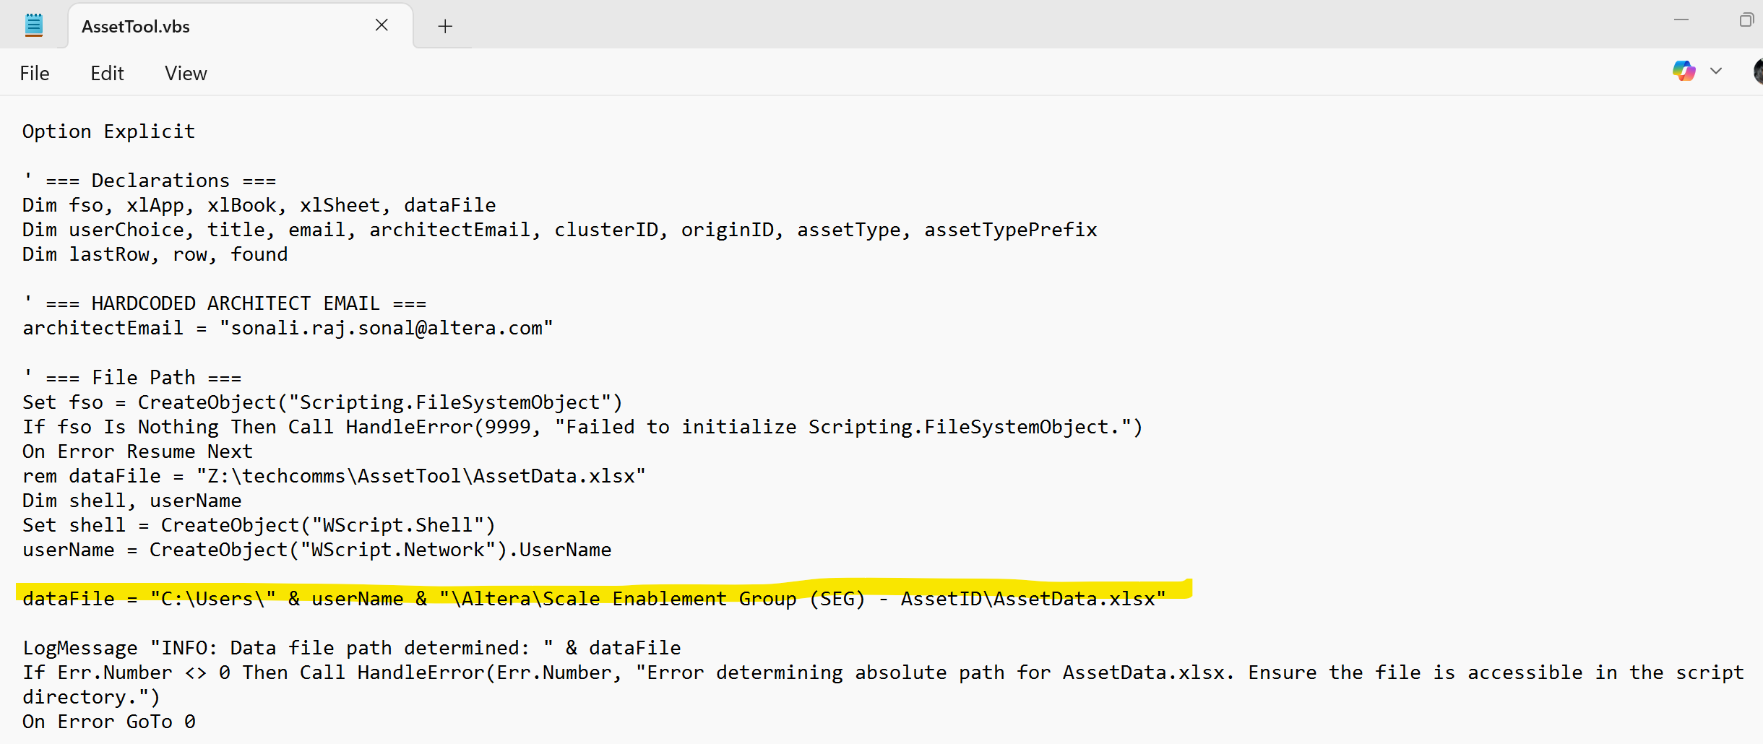

Change the line to -> dataFile = "C:\Users\" & userName & "\Altera\Scale Enablement Group (SEG) - LEGACY SITE - AssetID\AssetData.xlsx"

Save the file and try generating the id's.

